A-VIEW Server Developer Guide

(For v 4.0)

Amrita

E-Learning Research Lab

Amrita e-learning research lab

Contents

1. Introduction 4

2. Setting up your Development Environment 4

3. Checking out Source Code 4

4. Compiling the Java Server Tomcat Project 4

5. Validating the A-VIEW Server within Eclipse 10

6. To Export the Java code as War file 15

# Introduction

This document explains the steps involved in compiling the A-VIEW Server Project.

These are the high-level steps:

* Setup the development environment
* Checkout the code from Git
* Compile the Java Server.
* Install and Configure the Servers following the steps outlined in A-VIEW Server Installation Guide.

# Setting up your Development Environment

Please complete installation / configuration of these steps in your development environment first:

1. Install Eclipse Indigo
2. Install JDK Version 7
3. Install Tomcat 7.0.41
4. Install MySQL5.5.16
5. Install Git

# Checking out Source Code

Git clone the following repositories to your local development computer.

* aview-db-mysql
* aview-server-tomcat
* aview-content-php
* aview-video-fms

# Compiling the Java Server Tomcat Project

Once the prerequisites are taken care, please follow the below steps to import the project into workspace.

1. **Open Eclipse IDE.**
2. **From the Eclipse IDE, select *File*and choose *Import.* (Refer Fig: 1)**

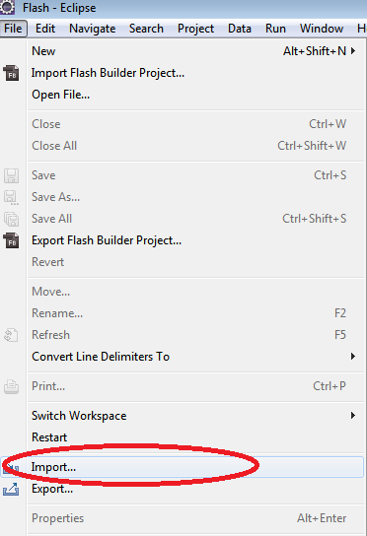

Fig: 1 – Select Import from menu

1. **In the *Import wizard,* select *Existing Projects into Workspace* in *General* and click *Next* Button.**

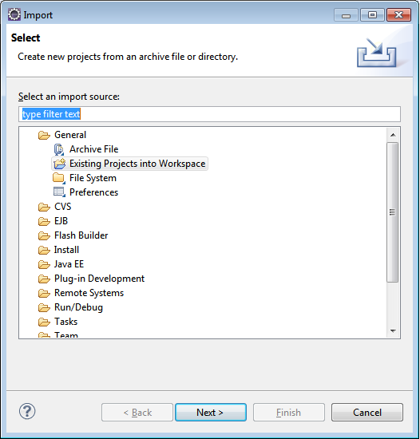

Fig: 2 –Import wizard

1. **Browse the project to be imported. After selecting the project click *Finish* button.**

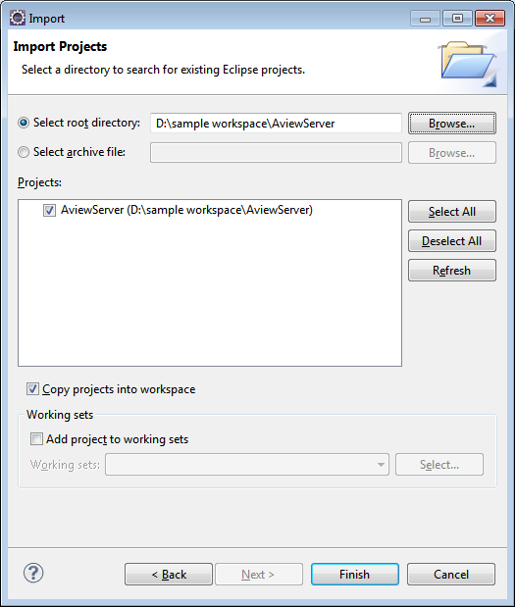

Fig: 3 –Import wizard to select the project

1. **Once the project is imported into the workspace, chances are there for getting compilation errors. If so, there are some setting problems which can be solved by the below steps**

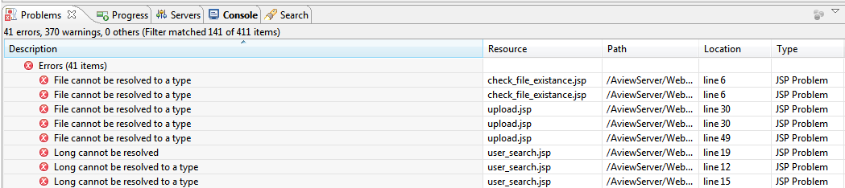

Fig: 4 – Problems view

1. **In Eclipse IDE,right click on the project and select Properties, and click *Java Build Path.* Then go to the *Libraries* tab.**

In the list of library you will see JRE System Library as unbounded (If JRE is not set correctly).

(Refer Fig: 5)

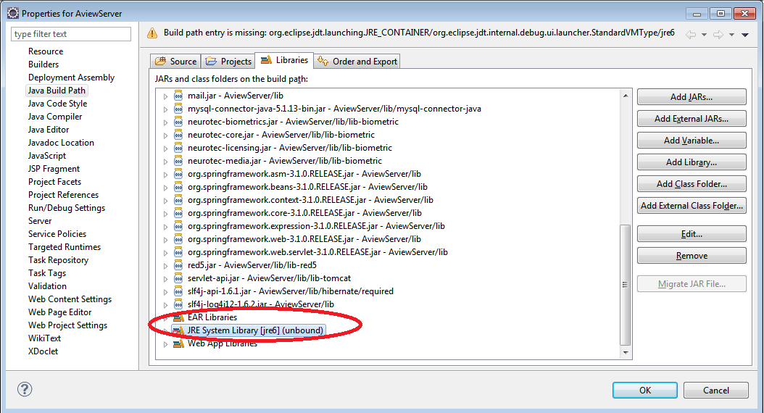

Fig: 5 – Properties

1. **Remove that JRE from the list and click *Add Library* button. (Refer Fig: 6)**

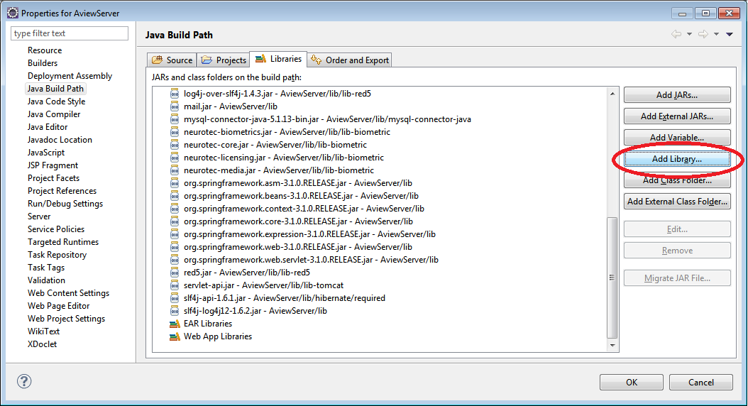

Fig: 6 – Java Build Path

1. **In *Add Library* Wizard, choose *JRE System Library* then click *Next.***

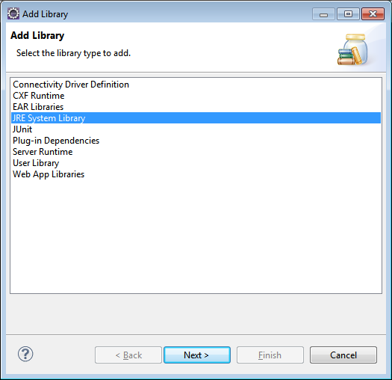

Fig: 7 – Add Library

1. **Select installed JRE and Click *Finish.***

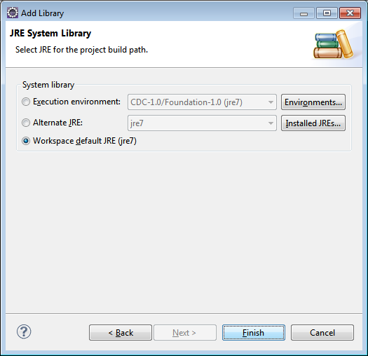

Fig: 8 – Add Library

1. **Install MySql in your development environment for validating the compiled java server.**

Please follow the steps in Section 5.2.1 of this document for configuring the Database.

# Validating the A-VIEW Server within Eclipse

**Step 1**

In Eclipse, take the ***Servers*** view. Do right click on it and choose ***New***, on choosing ***New*** you will get ***Server***. Click on the ***Server*** to get a new window to create new server. (Refer Fig: 1)

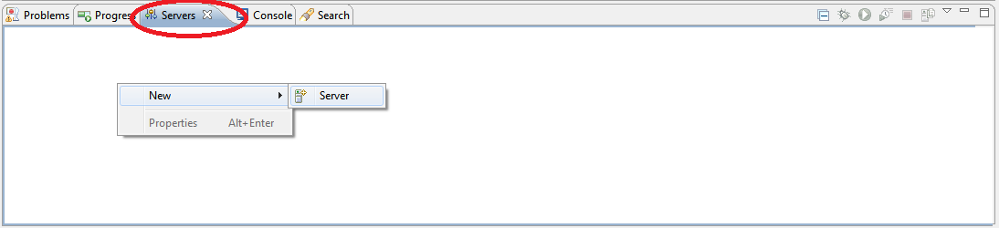

Fig: 9 Starting A-VIEW Server

**Step 2**

Select Tomcat server from ***Apache*** and click ***Next***.

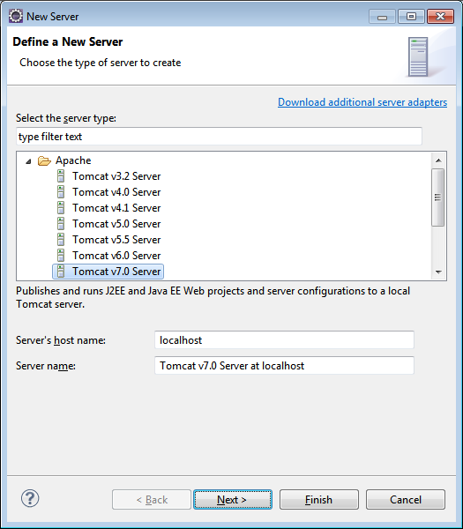

Fig: 10

**Step 3**

Give name to the server (can keep the default).If tomcat is already installed in your machine, provide the tomcat installation directory. Then select your installed JRE and click ***Next***.

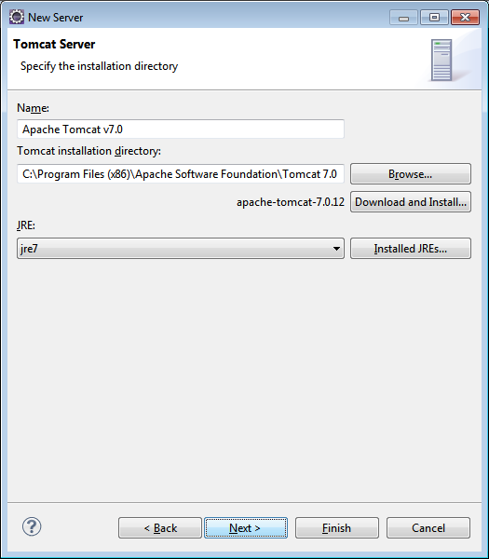

Fig: 11

**Step 4**

Select A-VIEW server from the available list and add it to the configured list. Click ***Next***.

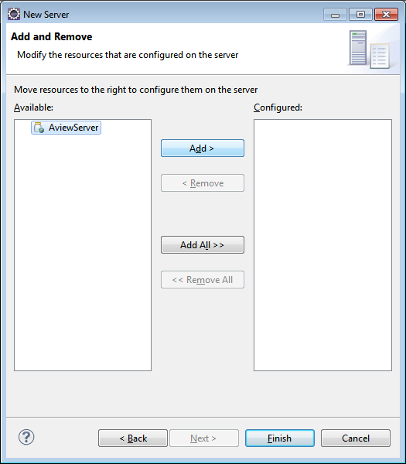

Fig: 12

**Step5**

After adding A-VIEW server to the configured list, click ***Finish***.

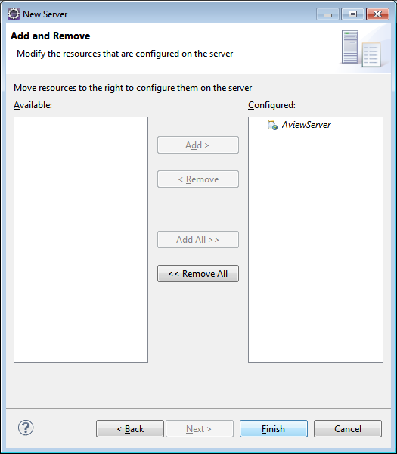

Fig: 13

On clicking ***Finish*** button a new server instance is added. You can see it in the ***Servers*** view.

(Refer Fig: 14)



Fig: 14

**Step 6**

Do right click on the tomcat server instance in the ***Servers*** view and select ***Start.***

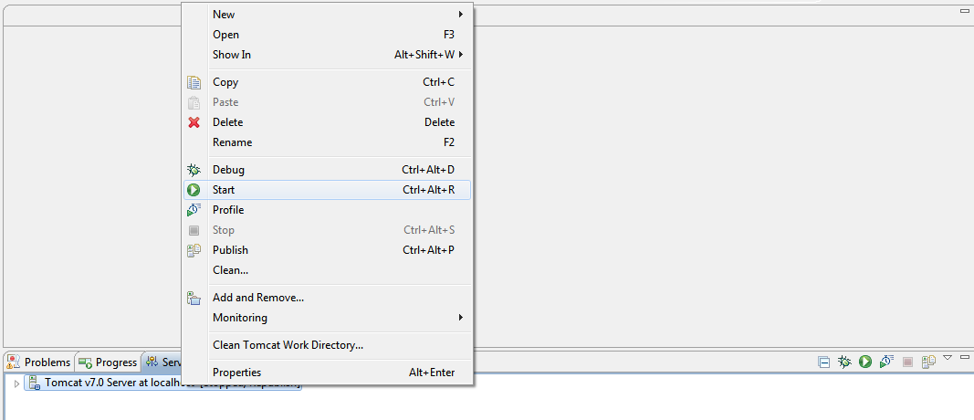

Fig: 15

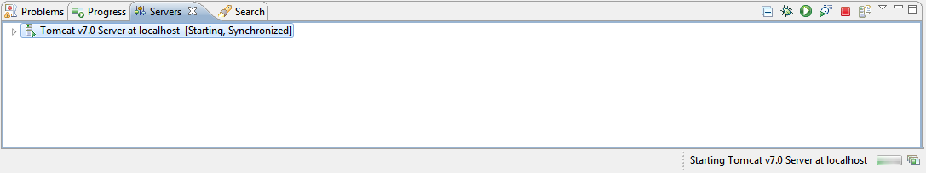

Fig: 16

This time A-VIEW server starts without any previous errors.

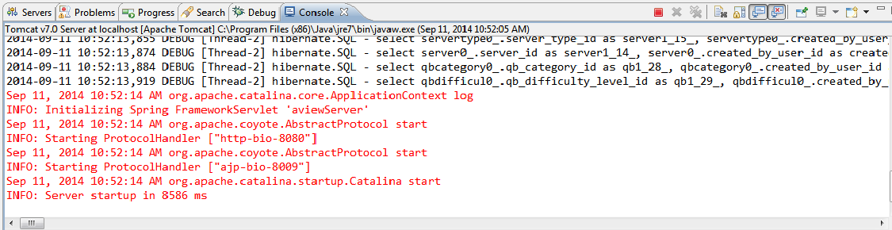

Fig: 17

# To Export the Java code as War file

* Right Click the project and select export war file

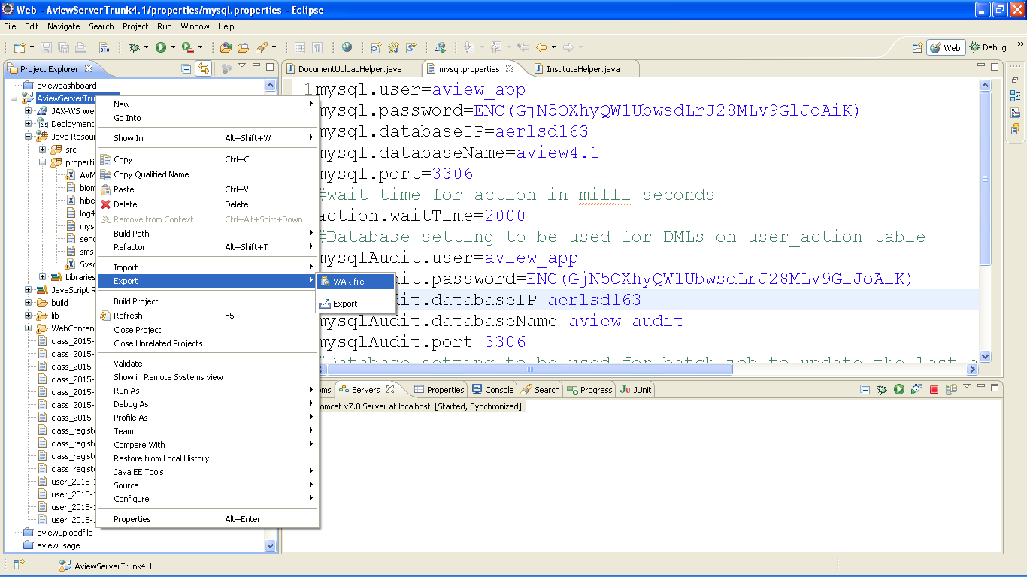

* Export the war file into the Tomcat webapps directory and click on Finish

